Context Level DFD (0-Level) for eAuto

Central Process
👉 eAuto Management System

🔹 Sub-Processes (high-level inside system)
- Login & Registration (handles authentication for Customer/Admin)
- Product Management (search, browse, manage product catalog)
- Cart & Order Management (add to cart, checkout, confirm order)
- Payment Processing (verify and confirm transactions)
- Supplier & Inventory Management (stock update, stock requests)
- Delivery Management (assign deliveries, track status)
- Reports & Analytics (sales, stock, delivery reports for Admin)

🔹 External Entities
- Customer
- Admin
- Supplier
- Delivery Staff

🔹 Data Stores
- D1: User Database (stores customer & admin login/registration details)
- D2: Product Database (stores product details, categories, pricing, discounts)
- D3: Cart & Order Database (stores cart info, order details, order history)
- D4: Payment/Transaction Database (stores payment confirmations, transaction logs)
- D5: Inventory Database (stores stock levels, supplier updates)
- D6: Delivery Database (stores delivery assignments, status updates)
- D7: Reports Database (aggregated data for admin reports/analytics)

🔹 Flow (Data Movement)

Customer ↔ eAuto System
- Request → Register/Login, Search Products, Add to Cart, Place Order, Payment, View Orders
- Response ← Login Confirmation, Search Results, Order Confirmation, Payment Status, Delivery Status
- Data Stores Accessed: User DB, Product DB, Cart & Order DB, Payment DB, Delivery DB

Admin ↔ eAuto System
- Request → Manage Products, Manage Orders, Manage Users, View Reports
- Response ← Confirmation Messages, Updated Data, Reports
- Data Stores Accessed: User DB, Product DB, Order DB, Reports DB, Inventory DB, Delivery DB

Supplier ↔ eAuto System
- Request → Provide Stock Info, Update Inventory
- Response ← Stock Confirmation, Order Requests
- Data Stores Accessed: Inventory DB

Delivery Staff ↔ eAuto System
- Request → Delivery Assignment, Update Delivery Status
- Response ← Delivery Details, Confirmation
- Data Stores Accessed: Delivery DB, Order DB

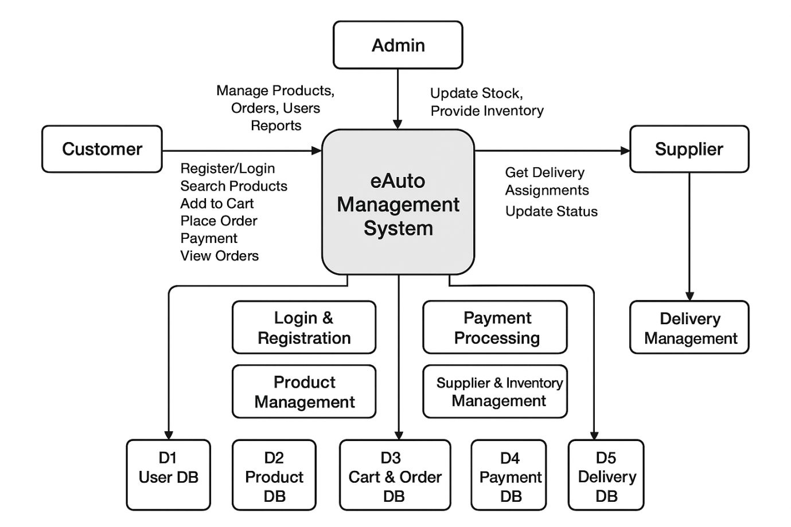
1st Level DFD – eAuto Management System

Processes (inside the system)
1.0 Login & Registration
- Input: Login/Register request (Customer/Admin)
- Output: Login confirmation
- Data Store: D1: User Database
2.0 Product Management
- Input: Product search request (Customer), Add/Update product (Admin)
- Output: Product info/search results
- Data Store: D2: Product Database
3.0 Cart & Order Management
- Input: Add to cart, Place Order (Customer)
- Output: Order confirmation
- Data Store: D3: Cart & Order Database
4.0 Payment Processing
- Input: Payment details (Customer)
- Output: Transaction confirmation
- Data Store: D4: Payment Records
5.0 Supplier & Inventory Management
- Input: Stock info update (Supplier)
- Output: Stock confirmation
- Data Store: D5: Inventory Database
6.0 Delivery Management
- Input: Delivery assignment request (System → Delivery Staff)
- Output: Delivery confirmation, Status update
- Data Store: D6: Delivery Records
7.0 Reports & Analytics
- Input: Report request (Admin)
- Output: Sales/Stock/Delivery reports
- Data Store: D7: Reports Database

External Entities
- Customer (Register/Login, Search Products, Add to Cart, Make Payment, Track Delivery)
- Admin (Manage Products, Orders, Users, Reports)
- Supplier (Stock Updates, Inventory Info)
- Delivery Staff (Order Delivery, Update Delivery Status)

Data Stores
- D1: User Database → stores customer/admin login info
- D2: Product Database → stores product details
- D3: Cart & Order Database → stores cart & order transactions
- D4: Payment Records → stores payment details
- D5: Inventory Database → manages stock levels
- D6: Delivery Records → stores delivery status and assignments
- D7: Reports Database → stores analytics data

Data Flows
- Customer ↔ 1.0 Login & Registration ↔ User Database
- Customer ↔ 2.0 Product Management ↔ Product Database
- Customer ↔ 3.0 Cart & Order Management ↔ Cart & Order Database
- Customer ↔ 4.0 Payment Processing ↔ Payment Records
- Supplier ↔ 5.0 Supplier & Inventory Management ↔ Inventory Database
- Delivery Staff ↔ 6.0 Delivery Management ↔ Delivery Records
- Admin ↔ 7.0 Reports & Analytics ↔ Reports Database

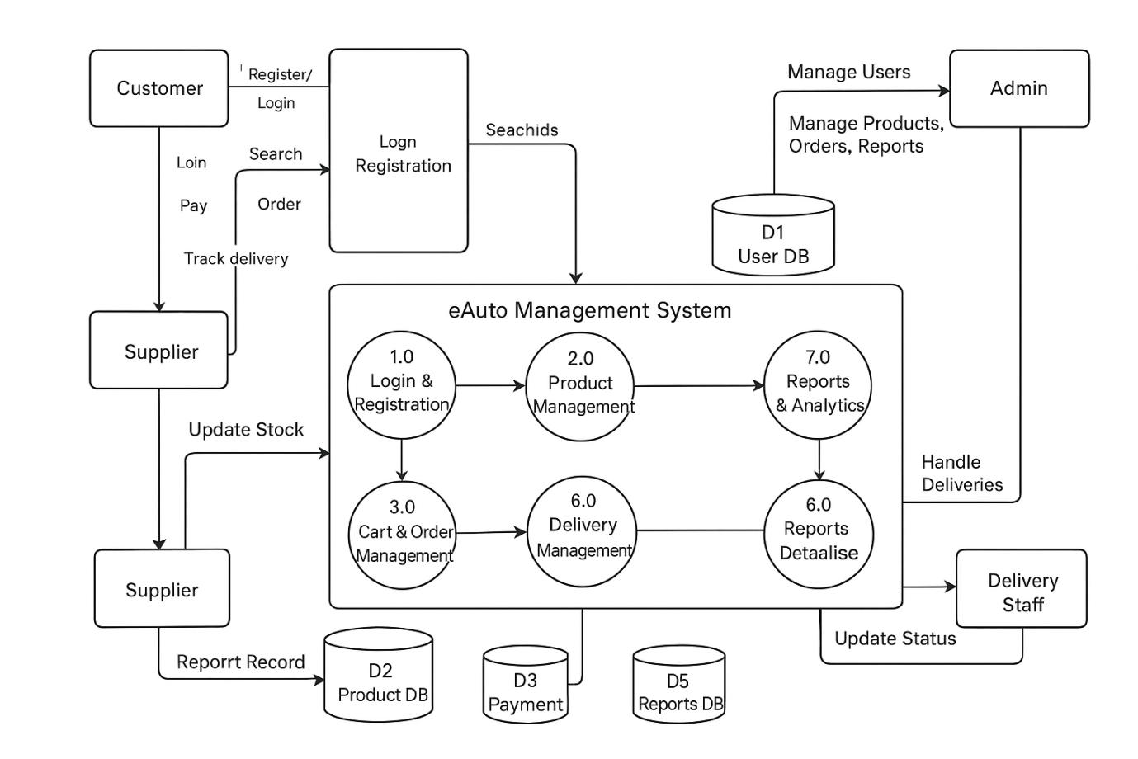

1.0 Login & Registration
External Entities:
- Customer
- Admin
Data Store:
- D1: User Database
Sub-Processes:
- 1.1 Register User
  - Input: Registration details (name, email, password, etc.) from Customer/Admin
  - Process: Validate details, store new record
  - Output: Registration confirmation
  - Data Store Interaction: Insert into D1: User Database
- 1.2 Login User
  - Input: Login credentials (username/email & password) from Customer/Admin
  - Process: Validate credentials
  - Output: Login success/failure message
  - Data Store Interaction: Verify credentials from D1: User Database
Data Flows:
- Customer/Admin → Registration details → 1.1 Register User
- 1.1 Register User → Store data → D1: User Database
- Customer/Admin → Login credentials → 1.2 Login User
- 1.2 Login User → Verify credentials → D1: User Database
- 1.1 Register User → Registration confirmation → Customer/Admin
- 1.2 Login User → Login confirmation/error → Customer/Admin
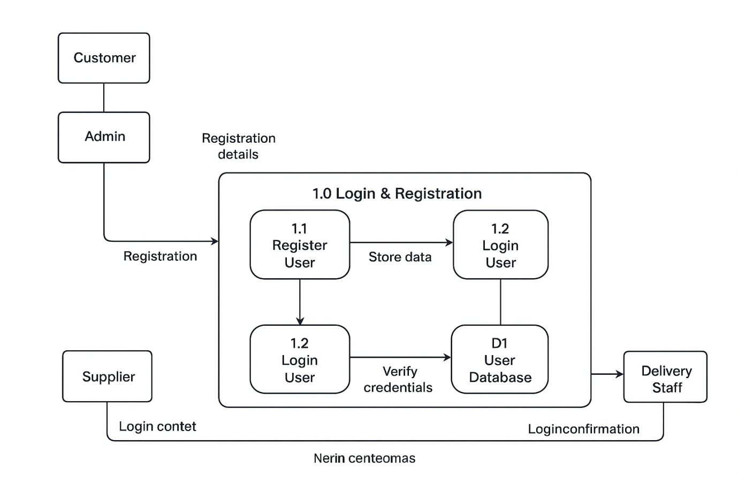

2.0 Product Management
External Entities:
- Customer
- Admin
Data Store:
- D2: Product Database
Sub-Processes:
- 2.1 Search Product
  - Input: Product search request from Customer
  - Process: Retrieve matching product info
  - Output: Search results (product list/details)
  - Data Store Interaction: Read from D2: Product Database
- 2.2 Add Product
  - Input: New product details from Admin
  - Process: Validate and insert new product
  - Output: Product added confirmation
  - Data Store Interaction: Insert into D2: Product Database
- 2.3 Update Product
  - Input: Updated product details from Admin
  - Process: Validate and update product record
  - Output: Update confirmation
  - Data Store Interaction: Update in D2: Product Database
Data Flows:
- Customer → Product search request → 2.1 Search Product
- 2.1 Search Product → Fetch product info → D2: Product Database
- D2: Product Database → Product details → 2.1 Search Product
- 2.1 Search Product → Search results → Customer
- Admin → Add product details → 2.2 Add Product
- 2.2 Add Product → Insert new product → D2: Product Database
- 2.2 Add Product → Add confirmation → Admin
- Admin → Update product details → 2.3 Update Product
- 2.3 Update Product → Update record → D2: Product Database
- 2.3 Update Product → Update confirmation → Admin
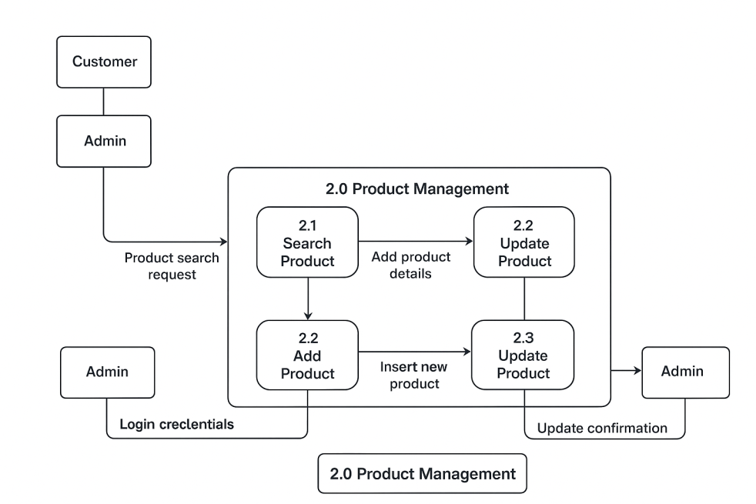

3.0 Cart & Order Management
External Entities:
- Customer
Data Store:
- D3: Cart & Order Database
Sub-Processes:
- 3.1 Add to Cart
  - Input: Product selection from Customer
  - Process: Validate product availability and add to cart
  - Output: Cart update confirmation
  - Data Store Interaction: Insert/Update cart record in D3: Cart & Order Database
- 3.2 View Cart
  - Input: Cart view request from Customer
  - Process: Retrieve all items from cart
  - Output: Cart details (products, quantity, total price)
  - Data Store Interaction: Read from D3: Cart & Order Database
- 3.3 Place Order
  - Input: Order request (checkout) from Customer
  - Process: Validate cart items, generate order ID, and store order
  - Output: Order confirmation
  - Data Store Interaction: Insert order details into D3: Cart & Order Database
Data Flows:
- Customer → Product selection → 3.1 Add to Cart
- 3.1 Add to Cart → Update cart data → D3: Cart & Order Database
- 3.1 Add to Cart → Cart update confirmation → Customer
- Customer → Cart view request → 3.2 View Cart
- 3.2 View Cart → Fetch cart items → D3: Cart & Order Database
- 3.2 View Cart → Cart details → Customer
- Customer → Place order → 3.3 Place Order
- 3.3 Place Order → Insert order data → D3: Cart & Order Database
- 3.3 Place Order → Order confirmation → Customer

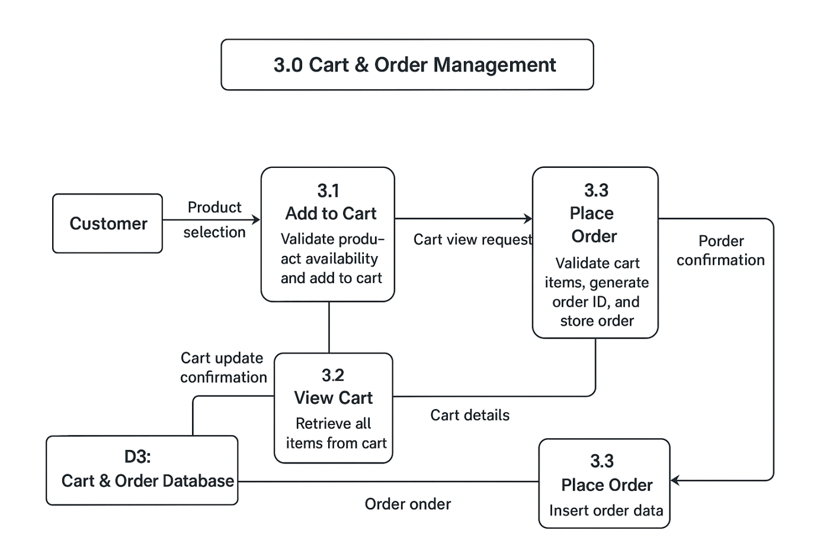
4.0 Payment Processing
External Entities:
- Customer
- Bank/UPI Gateway
Data Store:
- D4: Payment Records
Sub-Processes:
- 4.1 Initiate Payment
  - Input: Payment details (card/UPI/net banking/cash request) from Customer
  - Process: Validate input format and forward request
  - Output: Payment initiation status
  - Data Flow: Send details to Bank/UPI Gateway
- 4.2 Verify Payment Details
  - Input: Payment validation request from 4.1
  - Process: Bank/UPI Gateway checks account/card details
  - Output: Valid/Invalid response
  - Data Flow: Response sent back to 4.2 Verify Payment Details
- 4.3 Confirm Transaction
  - Input: Valid payment confirmation from Bank/UPI Gateway
  - Process: Generate transaction record and store in DB
  - Output: Transaction confirmation/Failure message
  - Data Store Interaction: Insert into D4: Payment Records
Data Flows:
- Customer → Payment details → 4.1 Initiate Payment
- 4.1 Initiate Payment → Forward request → Bank/UPI Gateway
- Bank/UPI Gateway → Verification response → 4.2 Verify Payment Details
- 4.2 Verify Payment Details → Validated result → 4.3 Confirm Transaction
- 4.3 Confirm Transaction → Store transaction → D4: Payment Records
- 4.3 Confirm Transaction → Transaction confirmation → Customer

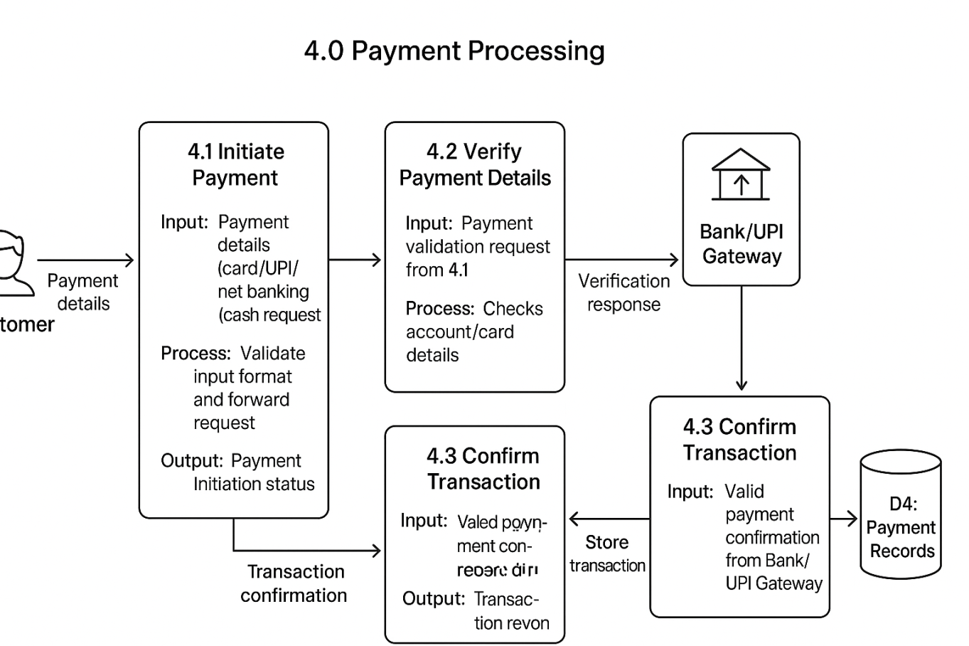

5.0 Supplier & Inventory Management
External Entities:
- Supplier
- Admin
Data Store:
- D5: Inventory Database
Sub-Processes:
- 5.1 Update Stock
  - Input: Stock info update from Supplier/Admin
  - Process: Validate stock details and update inventory records
  - Output: Stock update confirmation
  - Data Store Interaction: Update D5: Inventory Database
- 5.2 Check Inventory
  - Input: Inventory check request from Admin/System
  - Process: Retrieve current stock details
  - Output: Stock availability report
  - Data Store Interaction: Read from D5: Inventory Database
- 5.3 Generate Stock Report
  - Input: Report request from Admin
  - Process: Compile stock levels, shortages, and supplier info
  - Output: Inventory report
  - Data Store Interaction: Access data from D5: Inventory Database
Data Flows:
- Supplier/Admin → Stock info update → 5.1 Update Stock
- 5.1 Update Stock → Update records → D5: Inventory Database
- 5.1 Update Stock → Stock confirmation → Supplier/Admin
- Admin/System → Inventory check request → 5.2 Check Inventory
- 5.2 Check Inventory → Retrieve stock data → D5: Inventory Database
- 5.2 Check Inventory → Stock availability report → Admin/System
- Admin → Report request → 5.3 Generate Stock Report
- 5.3 Generate Stock Report → Access data → D5: Inventory Database
- 5.3 Generate Stock Report → Inventory report → Admin

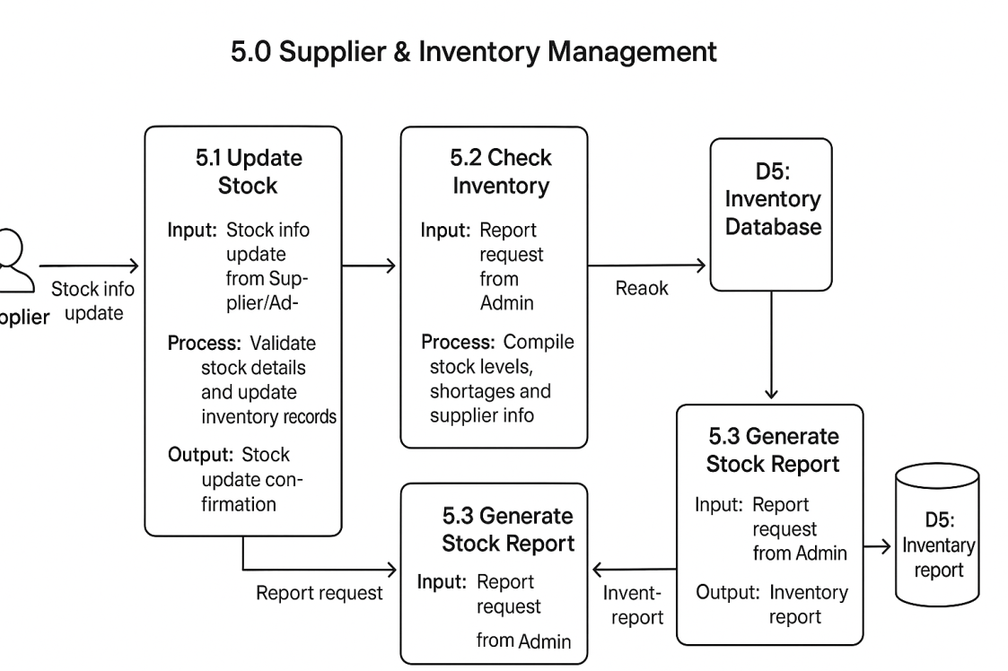

6.0 Delivery Management
External Entities:
- System
- Delivery Staff
- Customer
Data Store:
- D6: Delivery Records
Sub-Processes:
- 6.1 Assign Delivery
  - Input: Delivery assignment request from System
  - Process: Assign order to available Delivery Staff
  - Output: Delivery assignment confirmation
  - Data Store Interaction: Insert assignment into D6: Delivery Records
- 6.2 Update Delivery Status
  - Input: Delivery progress/status from Delivery Staff
  - Process: Record status updates (Out for delivery, Delivered, Failed)
  - Output: Updated delivery status
  - Data Store Interaction: Update D6: Delivery Records
- 6.3 Confirm Delivery
  - Input: Delivery completion info from Delivery Staff
  - Process: Validate and confirm successful delivery
  - Output: Delivery confirmation sent to Customer & System
  - Data Store Interaction: Store confirmation in D6: Delivery Records
Data Flows:
- System → Delivery assignment request → 6.1 Assign Delivery
- 6.1 Assign Delivery → Store assignment → D6: Delivery Records
- 6.1 Assign Delivery → Assignment confirmation → Delivery Staff
- Delivery Staff → Status update → 6.2 Update Delivery Status
- 6.2 Update Delivery Status → Update record → D6: Delivery Records
- 6.2 Update Delivery Status → Updated status → System/Customer
- Delivery Staff → Delivery completion info → 6.3 Confirm Delivery
- 6.3 Confirm Delivery → Store confirmation → D6: Delivery Records
- 6.3 Confirm Delivery → Delivery confirmation → Customer
- 6.3 Confirm Delivery → Delivery confirmation → System
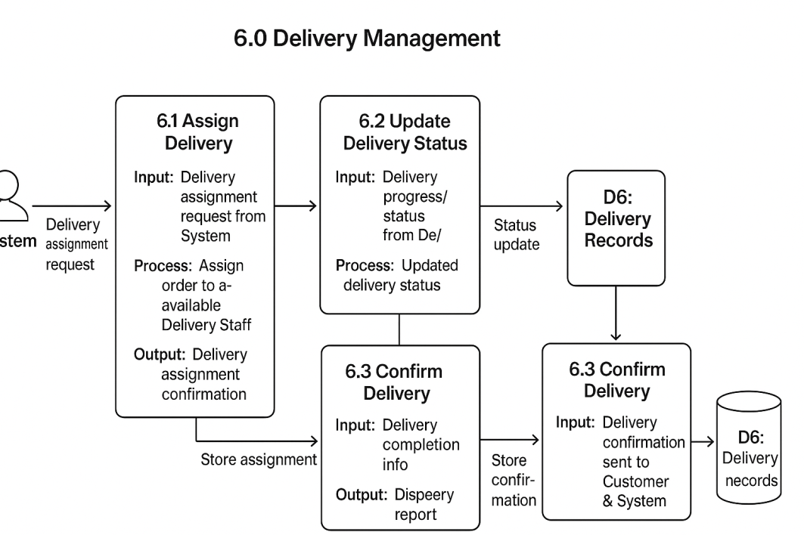

7.0 Reports & Analytics
External Entities:
- Admin
- System
Data Store:
- D7: Reports Database
Sub-Processes:
- 7.1 Generate Sales Report
  - Input: Report request (sales) from Admin
  - Process: Compile order and payment data to generate sales insights
  - Output: Sales report
  - Data Store Interaction: Retrieve/store in D7: Reports Database
- 7.2 Generate Stock Report
  - Input: Report request (stock) from Admin
  - Process: Collect inventory data, show shortages and availability
  - Output: Stock report
  - Data Store Interaction: Retrieve/store in D7: Reports Database
- 7.3 Generate Delivery Report
  - Input: Report request (delivery) from Admin
  - Process: Summarize delivery records, delays, completion rates
  - Output: Delivery report
  - Data Store Interaction: Retrieve/store in D7: Reports Database
Data Flows:
- Admin → Report request → 7.1 / 7.2 / 7.3
- 7.1 Generate Sales Report → Fetch sales data → D7: Reports Database
- 7.1 Generate Sales Report → Sales report → Admin
- 7.2 Generate Stock Report → Fetch inventory data → D7: Reports Database
- 7.2 Generate Stock Report → Stock report → Admin
- 7.3 Generate Delivery Report → Fetch delivery data → D7: Reports Database
- 7.3 Generate Delivery Report → Delivery report → Admin
- System → Data sync (orders, inventory, delivery) → D7: Reports Database
